XD01 – Create Customer Account

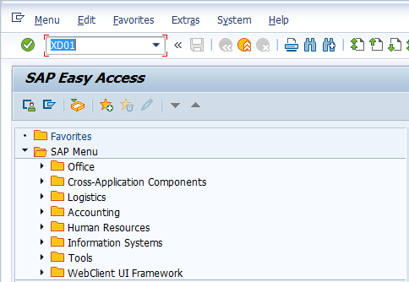
- Input XD01 in Transaction Box and press Enter key

Create Customer Initial Screen.
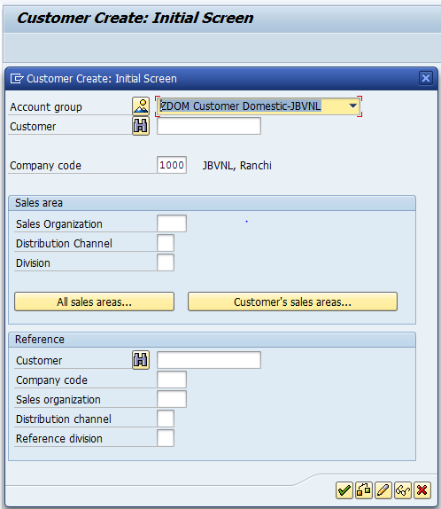

- Account group: Select relevant account group from drop-down list
- Company code: Input relevant company code
Press Enter key

Create Customer General Data Screen.

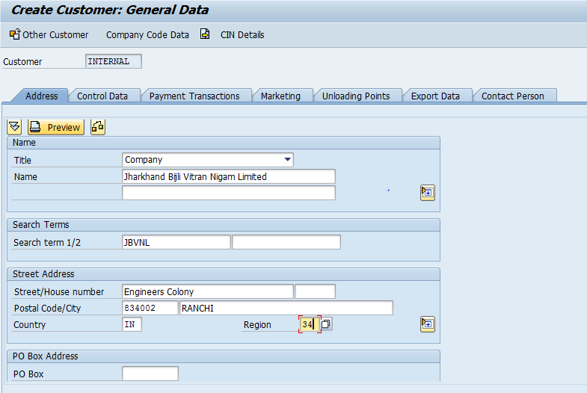

- Title: Select relevant title from the drop down list
- Name: Input customer name
- Search term 1/2: Input required/relevant search term
- Street/House number: Input steet and house number
- Postal Code/City: Input postal code and city
- Country: Select country code with the help of F4 key
- Region: Select region code with the help of F4 Key
Click on Company Code Data button

Create Customer Company Code Data Screen.

Account Management Tab

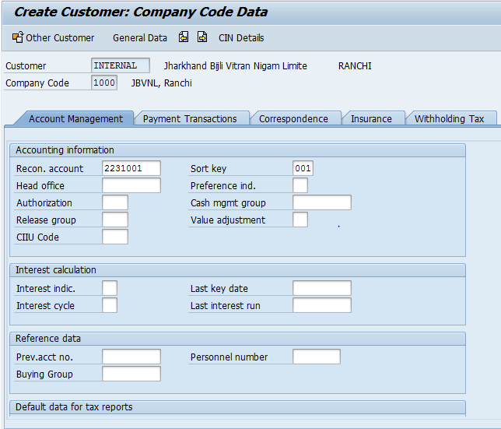

- Recon. account: Select the relevant reconcialiation account with the help of F4 key
- Sort Key: Select the relevant sort key with the help of F4 key
Select Payment Transactons tab

Create Customer Company Code Data Screen.

Payment Transaction Tab

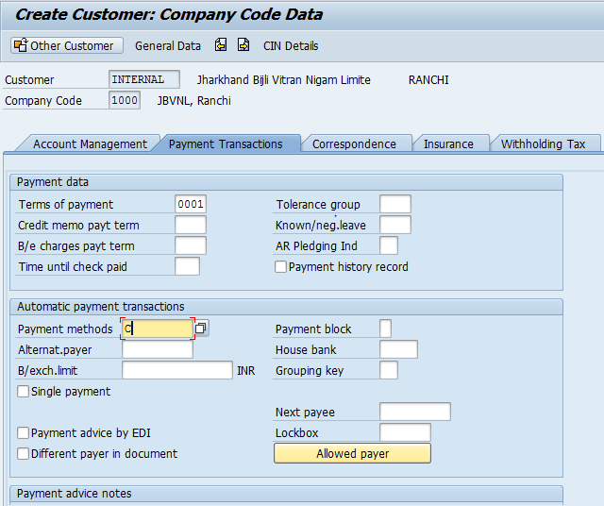

- Terms of payment: Select the relevant terms of payment with the help of F4 key
- Payment methods: Select the relevant payment metods with the help of F4 key

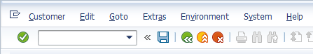

- Click on Save icon or press Ctrl+S keys to save the data

Customer was successfully created message appears at bottom of the screen

Manual End

